1. **ABSTRACT**

Every year, VERZEO launches the College Internship Drive to give NMAMIT students the chance to see industry standards firsthand. These internship drives at the NMAM Institute of Technology in Nitte are supported by the college and accepted as partial prerequisites for the award of the degree of Bachelor of Engineering in Computer Science & Engineering.

I used Flutter during my internship to develop mobile apps, which helped me better understand the principles behind developing interface components like widgets and layouts as well as when, how, and why to employ them.

The goal of the internship was to independently create three Android apps in order to have a solid understanding of the process of creating mobile apps and to investigate the many aspects of Flutter.

The training put a lot of emphasis on the business side of developing apps, like how and when to employ UI colors and what makes for a good user experience. I discovered ways to make myself more beneficial and employable in various sectors by knowing the strategies and tactics they implement to increase their user base.

2**. INTRODUCTION TO THE INDUSTRY**

Verzeo was introduced by CEO V.V. Subrahmanyam in 2018. He hopes his pupils will graduate prepared for the workforce. He believes that the divide between technology and education needs to be closed in order to give everyone in the country access to high-quality mentoring. Given the current context, we can infer that online learning is common. They understand how important it is for careerists to know where to go in order to attain their goals and celebrate victory because they are a responsible organisation. With the aid of Verzeo, several students made their professional decisions.

Verzeo, according to their claims, is an all-encompassing online learning environment that offers students all the tools they need to be prepared for the profession. In any home where a child has career goals, parents aim to propagate the notion that "everything is learning." Verzeo connects schools and workplaces through its flagship mentoring programmes. Even housewives, as well as newborns, adults, and other groups, can benefit from their training. They work very hard to provide pupils with a top-notch education that will better prepare them for a successful career. They have created a large number of programmes, such as Kids Programmes, Job Guarantee Programmes, and Pro-Degree Programmes, all of which are packed with hands-on activities and engaging discussions. In addition, they offer instruction in banking and accounting as well as vocational education. In order for students from all backgrounds to rely on Verzeo as their one-stop shop for online learning, they wish to offer a wide range of educational resource.

The CEO expects the company's 500 crore worth to be attained by the end of 2022 with over 900 employees on board. Studying at Verzeo is not limited to a single subject; in order to diversify its students' perspectives on growth and development. Verzeo offers its students several networking opportunities with business experts.

3**. DETAILS OF THE TRAINING UNDERGONE**

3 apps were developed for training purposes and they are as follows:

**3.1 Calculator App**

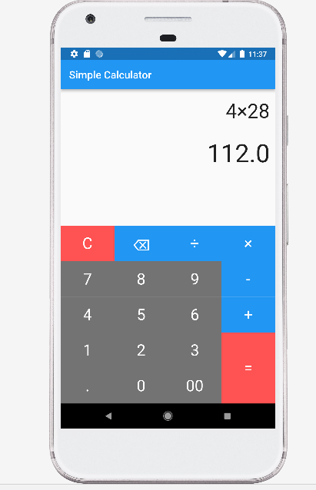

Figure 3.1 Calculator

Training started with learning of basics. To get familiar with buttons and programming of UI elements. A simple calculator app was developed.

As seen from Figure 3.1, it mainly consisted of buttons representing different numbers and operators. Linear layout was used to arrange the buttons and the screen while switch cases were used to switch between different operators.

**3.2 Quiz App**

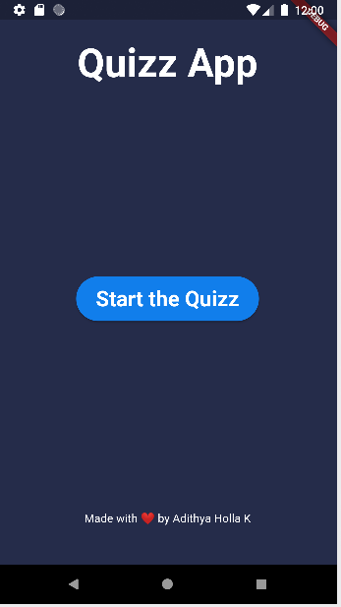 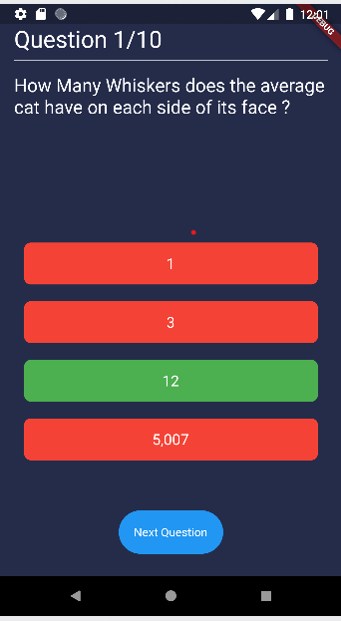

Figure 3.2.1 Home Screen of App Figure 3.2.2 Question Screen Of An App

After learning the fundamentals of user interface design, we built a quiz app with three screens. The main page, questions page, and results page are those three. There is a button labelled "Start Quiz" as shown in the figure 3.2.1 that, when pressed, takes the user to the questions screen, where the questions are listed as shown in the figure 3.2.2 .The use of the navigation push mechanism to move from the home page to the question page.

There are numerous possibilities made up of a widget called a button on the query page, as can be seen in the figure 3.2.2 .The options are selectable by the user. The user learns whether he made the right choices after making his selections. The user can respond to the following question by clicking the "next" button. The user can view the results page after answering the final question.

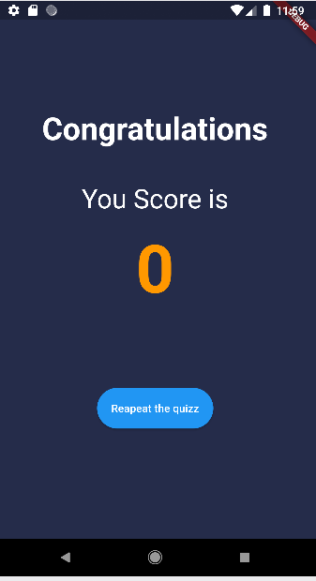

Figure 3.2.3 Result Page Of An App

The user can view his score on the results page after responding to all the questions. The navigator push method is used to navigate from the question page to the result page. In figure 3.2.3, there is a button labelled "Repeat quiz" that allows the user to repeat the quiz they previously took.

**3.3 Candidate Profile App**

|  |  |  |  |
| --- | --- | --- | --- |
|  |  |  |  |

Figure 3.3.1 Home Page Of An App Figure 3.3.2 Introduction Page Of An App

We create a profile app that allows users to view specific personal details. The four screens are the home screen, the introduction screen, the skills screen, and the education screen. We can see four buttons in figure 3.3.1 above, including introduction, education, and skills. Any button can be clicked by the user to view the details. The navigator's push mechanism is used for this navigation. By using the navigator pop approach, the user can return to the home page from any of the screens. The user moves from the home screen to the introduction screen when they click the introduction button. The user can view their biographical information on this screen. In figure 3.3.2, we can see a button labelled "Go back" which, when clicked, returns the user to the home screen.

|  |  |  |  |  |  |  |
| --- | --- | --- | --- | --- | --- | --- |
|  |  |  |  |  |  |  |

Figure 3.3.3 Education Page of an AppFigure 3.3.4 Skill Page of an App

When a user clicks the education button, they are taken from the home screen to the details screen for their education. On this screen, the user can see information about their education. Figure 3.3.3 shows a "Go back" button that, when clicked, takes the user back to the home screen. When the user clicks the skill button, they are taken from the home screen to the skill information panel. On this screen, the user can see information about their talents. Figure 3.3.4 shows a "Go back" button that, when clicked, takes the user back to the home screen.

4. **CONCLUSION**

I worked on the creation of three separate Android apps, and as a result, I have gained more experience. My four weeks of internship also allowed me to learn some of the small strategies they employ to boost their productivity.

I feel more confident in myself now that my internship is over, and I want to thank VERZEO for allowing me to use their platform for this incredible experience.

5**. REFERENCES**

1. <https://docs.flutter.dev/reference/tutorials>
2. <https://stackoverflow.com/>
3. <https://www.verzeo.com/>
4. <https://docs.flutter.dev/development/ui/layout/tutorial>
5. <https://docs.flutter.dev/get-started/install/windows>
6. <https://www.google.com/>
7. <https://developer.android.com/>
8. <https://www.youtube.com/>